Coffee Name | PB EAAGADS Estate
Country of Origin/ Region | KENYA, KIAMBU COUNTY
Name/ Type of producer | KOFINAF ESTATE GROUP, Owned by Kofinaf Co. Ltd
Taylor Winch (Coffee) Ltd
Coffee - FACTSHEET

Region and Farm Information | Farm Size | Approx. 205 hectares under coffee
 | Altitude | Approx. 1,596 metres a.s.l.
 | Soil Type | Deep red volcanic soils, rich in organic matter.
 | Variety | Mostly SL 28 , SL 34 and Ruiru 11.
 | Rainfall | Approx. 1,000 mm per annum
Harvest | Early Crop  Late Crop | June / July / Aug (minimal quantities)  Oct / Nov / Dec
Processing | Processing Method | Timely and selective hand picking is carried out in Eaagards Estate. Cherry is delivered to wet mill the same day it is picked. Cherry sorting is carried out at the wet mill prior to the pulping. Red ripe cheries are separated from underipes, overipes and foreign matter. Processing utilizes clean river water (wet processing) that is recirculated before disposal into seepage pits. Dry fermentation occurs overnight or until the slippery mucilage is loosened and the wet parchment becomes rough to the touch. This is followed by washing and grading in long washing channels, using clean water, before a final 12 hour underwater soak to eliminate any remaining mucilage. Sun drying on rasied tables is undertaken for minimum 14 days before the dry parchment is then stored in large conditioning bins awaiting consolidation into millable quantities.
 | Mill Process | Hulled and graded by size and density, bagged off for sale.
 | Screen Size | Above Screen 16
Volume of Production |  | Approx. 200 metric tons green bean per annum
Shipment Period |  | March
Packaging |  | Hermetically lined jute export bags
Certification |  | RFA, 4C & C.A.F.E practices
Nearest town |  | Thika town
 |  | 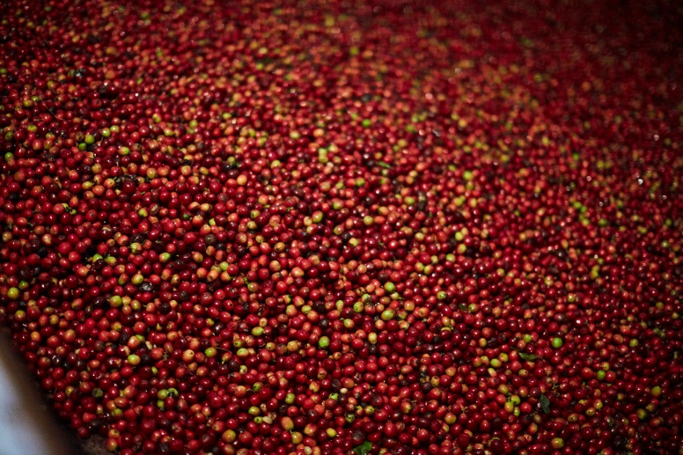
 |  | 