Coffee Name | KENYA AB KIANJUKI
Country of Origin/ Region | KENYA, EMBU COUNTY.
Name/ Type of producer | KIRURUMWE FARMERS COOPERATIVE SOCIETY  Consists of Kevote, Kianjuki and Ngaindeithia Factories.  Total active members-2600
Taylor Winch (Coffee) Ltd
Coffee - FACTSHEET

Region and Farm Information | Farm Size | Approx. 200 hectares under coffee
 | Altitude | Approx. 1400-1600 metres a.s.l.
 | Soil Type | Deep red volcanic soils, rich in organic matter.
 | Variety | SL 28, SL34 constitute 85% while the rest is Ruiru 11 and a few have planted Batian.
 | Rainfall | Approx. 1400 mm per annum
Harvest | Early Crop  Late Crop | Jun/July/Aug  Oct/Nov/Dec
Processing | Processing Method | Timely and selective hand picking is carried out in Kianjuki. Cherry is delivered to wet mill the same day it is picked. Cherry sorting is carried out at the wet mill prior to the pulping. Red ripe cheries are separated from underipes, overipes and foreign matter. Processing utilizes clean river water (wet processing) that is recirculated before disposal into seepage pits. Sun drying on raised tables is done before delivery of the coffee to the dry mill for secondary processing..
 | Mill Process | Hulled and graded by size and density, bagged off for sale.
 | Screen Size | Above Screen 16
Volume of Production |  | Approx. 250 metric tons green bean per annum
Packaging |  | Hermetically lined jute export bags
Shipment |  | March
Location and membership |  | -The Coop is located within Makengi location of Runyenjes sub-county, in Embu County on the southern slopes of Mount Kenya about 150km north of Nairobi City.  -Has around 1000 farmers.
Management |  | The Coop is managed by an elected board of management of 5 members elected democractically by members during annual general meetings. Two of the wet mills will each give 2 members and one from the remaining mill. The members are appointed by the farmers duribg the annual general meeting.
Employees |  | Year round- 18  Peak seasons- 40
Certification |  | Café practices
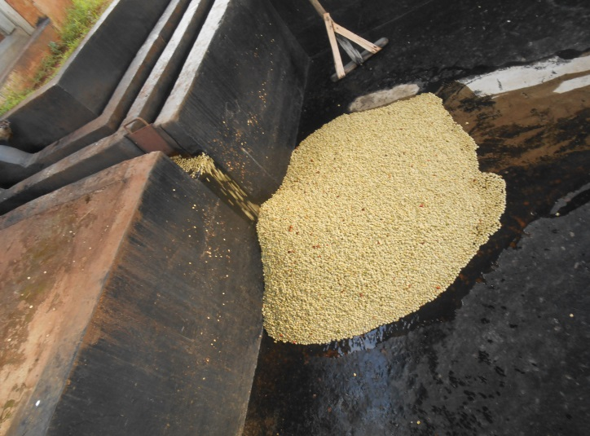
Parchment coffee after pulping

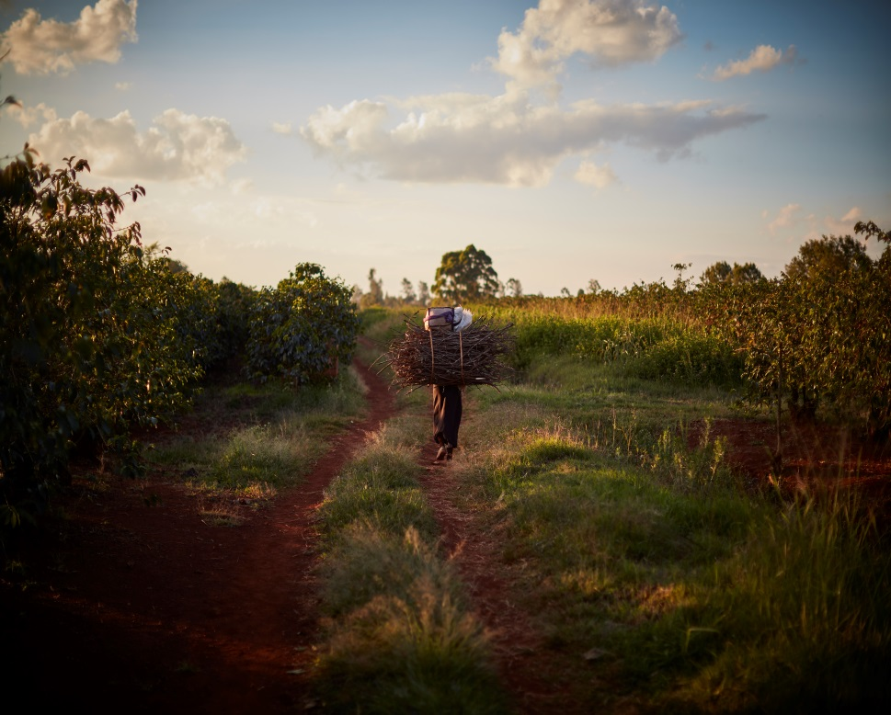
A woman carrying firewood on her back most probably for cooking walking past a coffee bush.

